Note:

* For all users in the database, there password should be 123 in case you would like to login with them.

Pictures:

1 Registration Page without info:

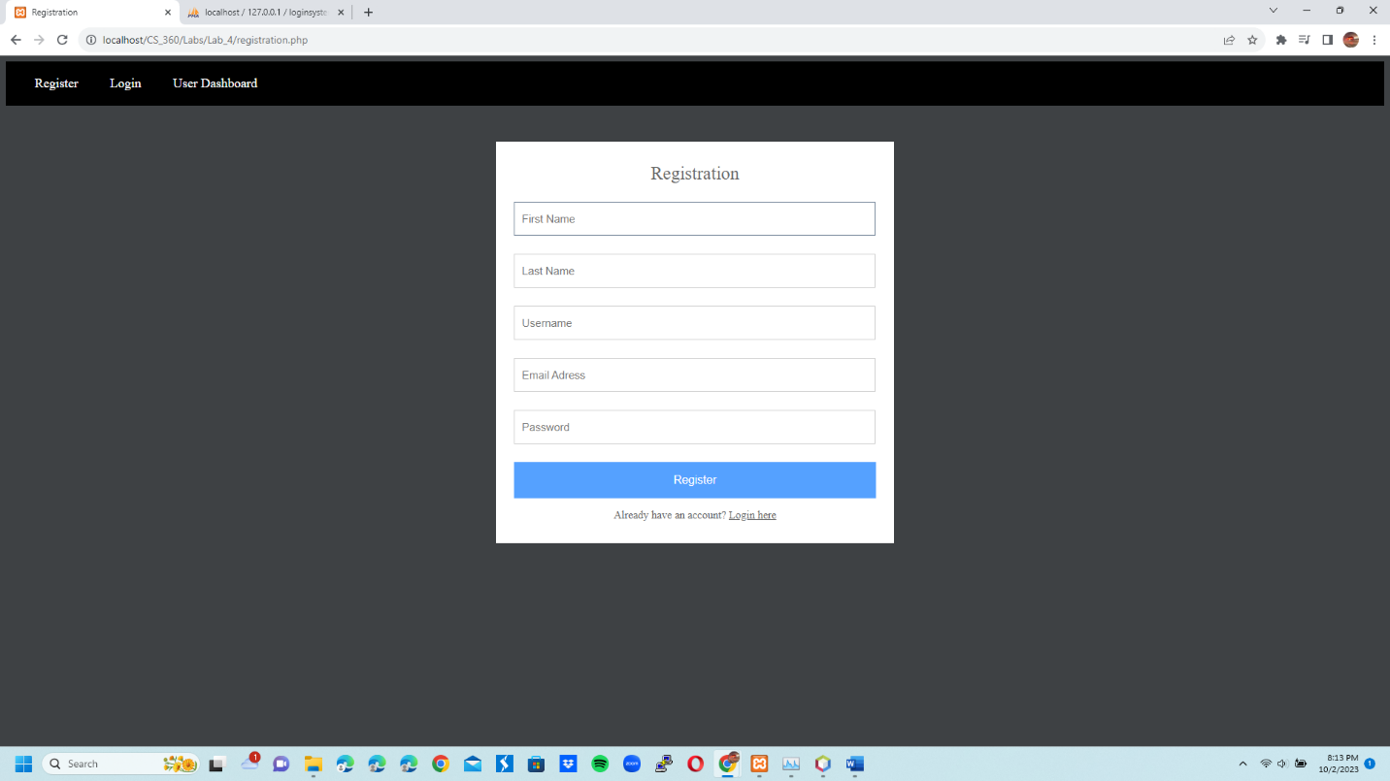

2 Registration Page with new info for new user John Brown:

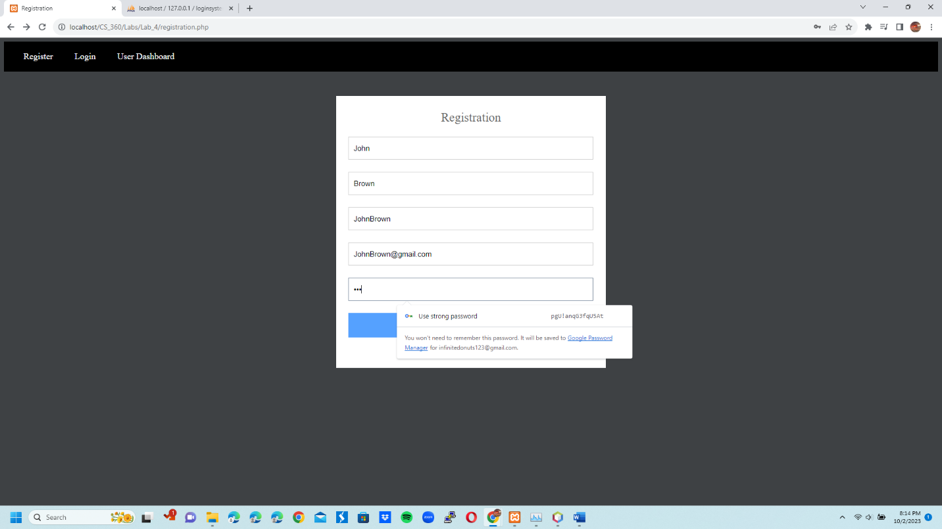

3 User sucessfully created: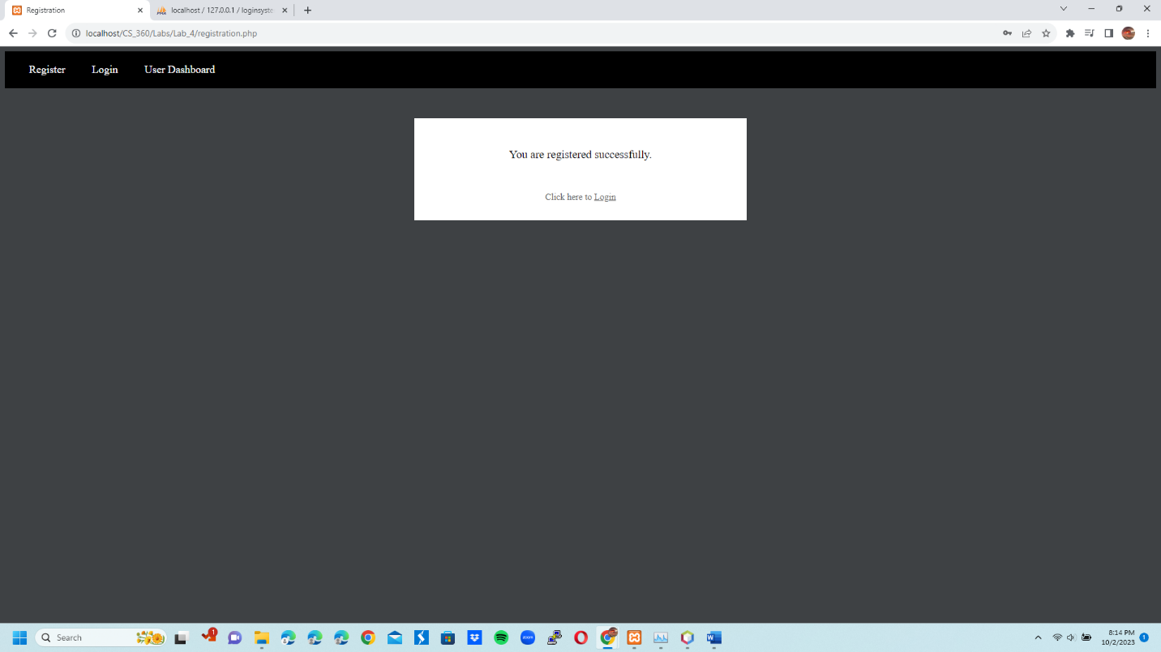

4 Login Page with no info: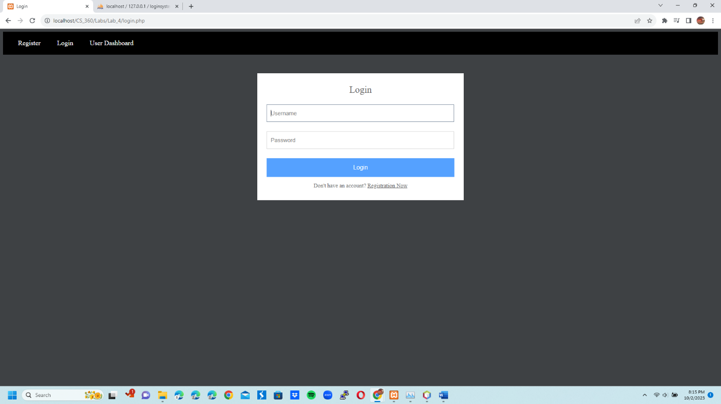

5 Login Page with John Brown user info: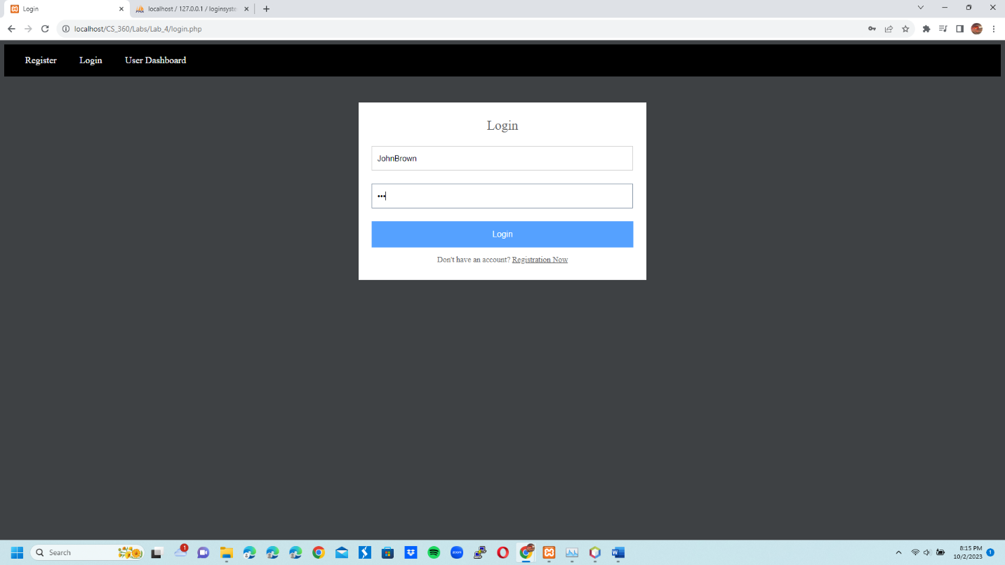

6 User Dashboard Page logged in as John Brown: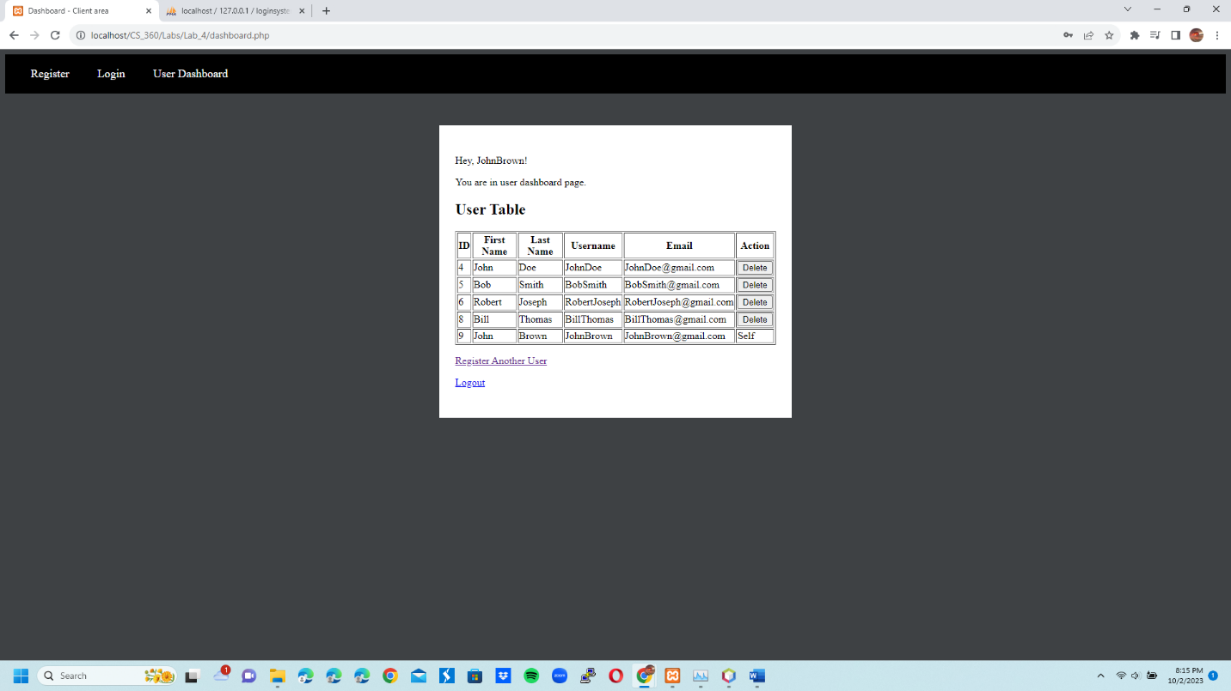

7 Login Page with Bob Smith info: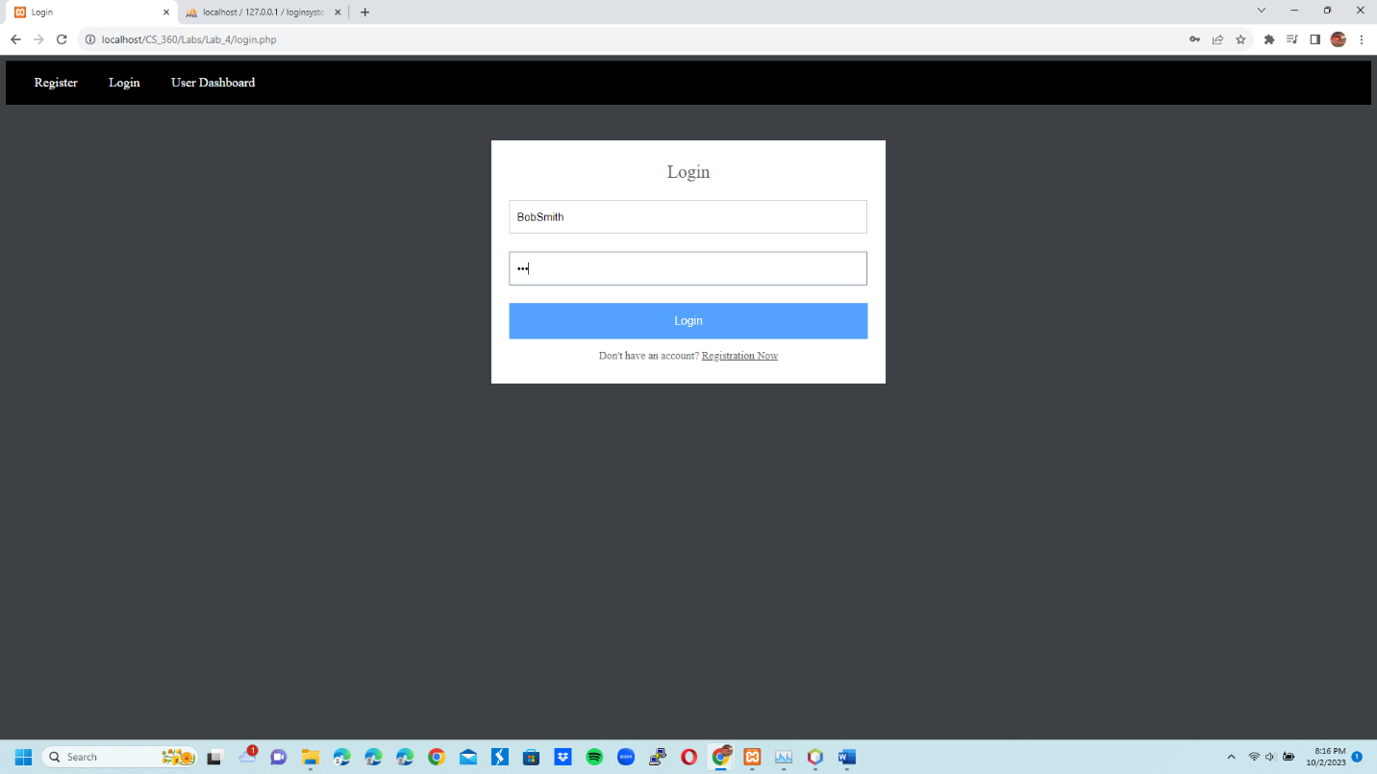

8 User Dashboard Page logged in as Bob Smith: 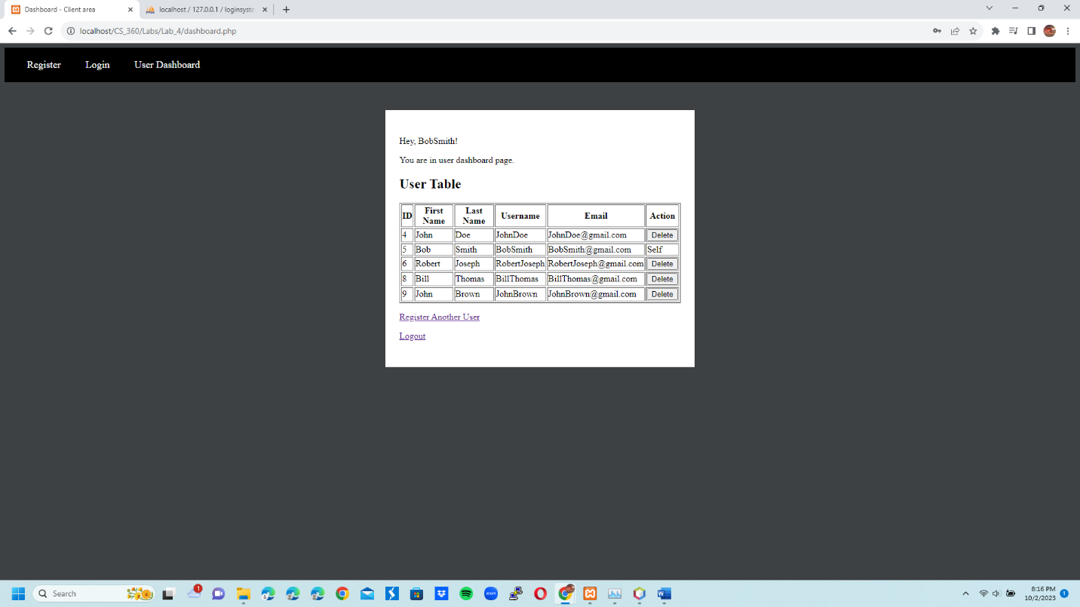

9 User Dashboard logged in as Bob Smith after other users have been deleted from database from the User Dashboard page: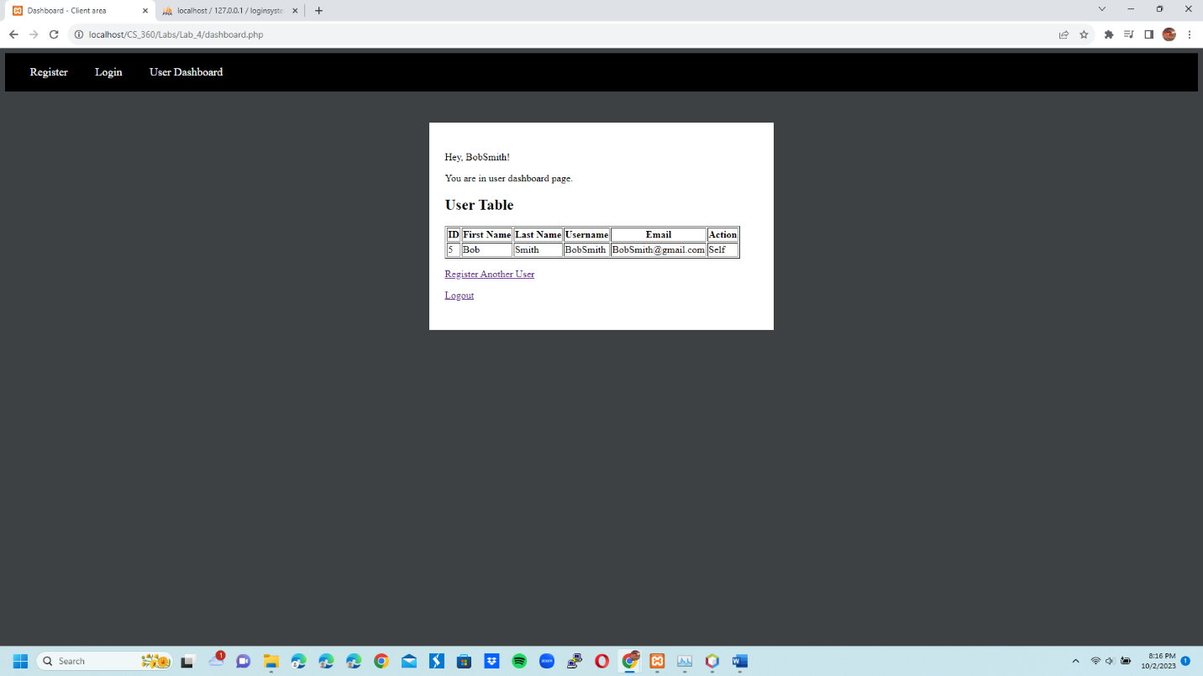

10 users table in loginsystem database after John Brown was added – note there were existing users before he was added: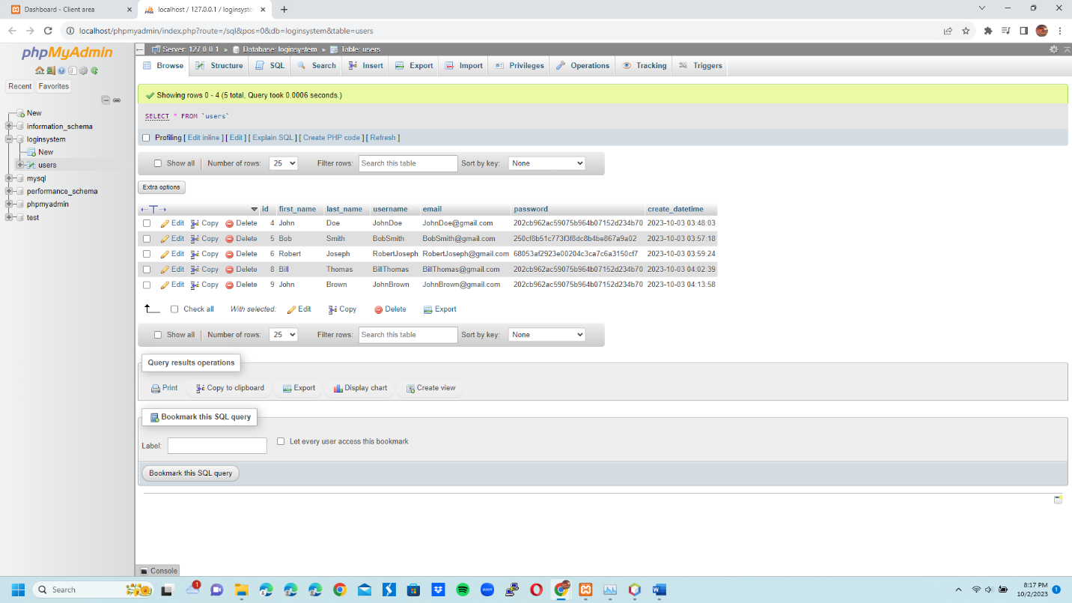

11 users table in loginsystem database after Bob Smith deleted everyone: